Internship project

Gautham Nagaraj

Austin Nixon

### Student Performanace In Exams

# INTRODUCTION

# *1.1 Overview - To understand the influence of various factors like economic, personal and social on the students performance*

# *1.2  Purpose :*

# *1. How to imporve the students performance in each test*

# *2. What are the major factors influencing the test scores*

# *3. Effectiveness of test preparation course*

LITERATURE SURVEY

2.1  Existing problem- *With the wide usage of computers and internet, there has recently been a huge increase in publicly available data that can be analysed. Be it online sales information, website traffic, or user habits, data is generated every day. Such a large amount of data presents both a problem and an opportunity. The problem is that it is difficult for humans to analyse such large data. The opportunity is that this type of data is ideal for computers to process, because it is stored digitally in a well-formatted way, and computers can process data much faster than humans. In schools and higher educational institutes, many students have to struggle hard to pass exams since there is no dedicated support offered to students who need special attention in the relevant courses.*

2.2 Proposed solution:

*This project examines the application of machine learning algorithms to predict whether a student will be successful or not. Machine learning techniques can be utilized for students’ grades prediction in different courses. Such techniques would help students to improve their performance based on predicted grades and would enable instructors to identify such individuals who might need assistance in the courses . This is best suited for online courses*

3 THEORITICAL ANALYSIS:

**Software designing**:

**Regression analysis** consists of a set of machine learning methods that allow us to predict a continuous outcome variable (y) based on the value of one or multiple predictor variables (x).

Briefly, the goal of regression model is to build a mathematical equation that defines y as a function of the x variables. Next, this equation can be used to predict the outcome (y) on the basis of new values of the predictor variables (x).

Artificial Intelligence has become prevalent recently. People across different disciplines are trying to apply AI to make their tasks a lot easier. For example, economists are using AI to predict future market prices to make a profit, doctors use AI to classify whether a tumor is malignant or benign, meteorologists use AI to predict the weather, HR recruiters use AI to check the resume of applicants to verify if the applicant meets the minimum criteria for the job, etcetera. The impetus behind such ubiquitous use of AI is machine learning algorithms. For anyone who wants to learn ML algorithms but hasn’t gotten their feet wet yet, you are at the right place. The rudimental algorithm that every Machine Learning enthusiast starts with is a linear regression algorithm. Therefore, we shall do the same as it provides a base for us to build on and learn other ML algorithms.

**4. EXPERIMENTAL INVESTIGATIONS:**

Today I am going to talk about experimentation in data science, why it is so important and some of the different techniques that we might consider using when AB testing is not appropriate. Experiments are designed to identify causal relationships between variables and this is a really important concept in many fields and particularly relevant for data scientists today. Let’s say we are a data scientist working in a product team. In all likelihood, a large part of our role will be to identify whether new features will have a positive impact on the metrics we care about. i.e. if we introduce a new feature making it easier for users to recommend our app to their friends, will this improve user growth? These are the types of questions that product teams will be interested in and experiments can help provide an answer. However, causality is rarely easy to identify and there are many situations where we will need to think a bit deeper about the design of our experiments so we do not make incorrect inferences. When this is the case, we can use often use techniques taken from econometrics and I will discuss some of these below. Hopefully, by the end, you will get a better understanding of when these techniques apply and also how to use them effectively.

**Web Search Engine:** One of the reasons why search engines like google, bing etc work so well is because the system has learnt how to rank pages through a complex learning algorithm.

**Photo tagging Applications:** Be it facebook or any other photo tagging application, the ability to tag friends makes it even more happening. It is all possible because of a face recognition algorithm that runs behind the application.

**Spam Detector:** Our mail agent like Gmail or Hotmail does a lot of hard work for us in classifying the mails and moving the spam mails to spam folder. This is again achieved by a spam classifier running in the back end of mail application.

**5 FLOWCHART:**

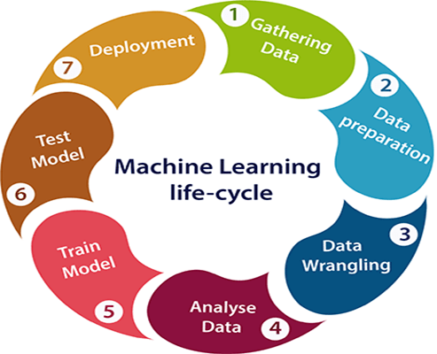

**6 RESULT:**

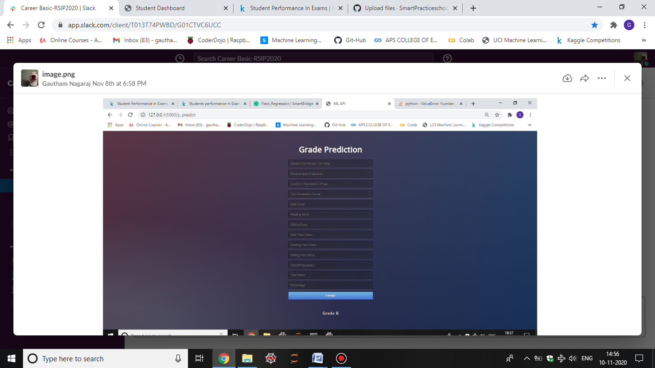

* The Final result contain the grade predication of a student.
* The various inputs given determine the grade
* Prediction is based on how the student is preparing,gender,lunch,etc.

7 **ADVANTAGES & DISADVANTAGES:**

### Advantages

#### 1. Easily identifies trends and patterns

Machine Learning can review large volumes of data and discover specific trends and patterns that would not be apparent to humans. For instance, for an e-commerce website like Amazon, it serves to understand the browsing behaviors and purchase histories of its users to help cater to the right products, deals, and reminders relevant to them. It uses the results to reveal relevant advertisements to them.

#### 2. No human intervention needed (automation)

With ML, you don’t need to babysit your project every step of the way. Since it means giving machines the ability to learn, it lets them make predictions and also improve the algorithms on their own. A common example of this is anti-virus softwares; they learn to filter new threats as they are recognized. ML is also good at recognizing spam.

#### 3. Continuous Improvement

As [**ML algorithms**](https://data-flair.training/blogs/machine-learning-algorithms/) gain experience, they keep improving in accuracy and efficiency. This lets them make better decisions. Say you need to make a weather forecast model. As the amount of data you have keeps growing, your algorithms learn to make more accurate predictions faster.

#### 4. Handling multi-dimensional and multi-variety data

Machine Learning algorithms are good at handling data that are multi-dimensional and multi-variety, and they can do this in dynamic or uncertain environments.

#### 5. Wide Applications

You could be an e-tailer or a healthcare provider and make ML work for you. Where it does apply, it holds the capability to help deliver a much more personal experience to customers while also targeting the right customers.

### Disadvantages

With all those advantages to its powerfulness and popularity, Machine Learning isn’t perfect. The following factors serve to limit it:

#### 1. Data Acquisition

Machine Learning requires massive data sets to train on, and these should be inclusive/unbiased, and of good quality. There can also be times where they must wait for new data to be generated.

#### 2. Time and Resources

ML needs enough time to let the algorithms learn and develop enough to fulfill their purpose with a considerable amount of accuracy and relevancy. It also needs massive resources to function. This can mean additional requirements of computer power for you.

#### 3. Interpretation of Results

Another major challenge is the ability to accurately interpret results generated by the algorithms. You must also carefully choose the algorithms for your purpose.

#### 4. High error-susceptibility

[**Machine Learning**](https://en.wikipedia.org/wiki/Machine_learning) is autonomous but highly susceptible to errors. Suppose you train an algorithm with data sets small enough to not be inclusive. You end up with biased predictions coming from a biased training set. This leads to irrelevant advertisements being displayed to customers. In the case of ML, such blunders can set off a chain of errors that can go undetected for long periods of time. And when they do get noticed, it takes quite some time to recognize the source of the issue, and even longer to correct it.

8. APPLICATIONS:

**1. Virtual Personal Assistants**

Siri, Alexa, Google Now are some of the popular examples of virtual personal assistants. As the name suggests, they assist in finding information, when asked over voice. All you need to do is activate them and ask “What is my schedule for today?”, “What are the flights from Germany to London”, or similar questions. For answering, your personal assistant looks out for the information, recalls your related queries, or send a command to other resources (like phone apps) to collect info. You can even instruct assistants for certain tasks like “Set an alarm for 6 AM next morning”, “Remind me to visit Visa Office day after tomorrow”.

Machine learning is an important part of these personal assistants as they collect and refine the information on the basis of your previous involvement with them. Later, this set of data is utilized to render results that are tailored to your preferences.

Virtual Assistants are integrated to a variety of platforms. For example:

* Smart Speakers: Amazon Echo and Google Home
* Smartphones: Samsung Bixby on Samsung S8
* Mobile Apps: Google Allo

**2. Predictions while Commuting**

*Traffic Predictions*: We all have been using GPS navigation services. While we do that, our current locations and velocities are being saved at a central server for managing traffic. This data is then used to build a map of current traffic. While this helps in preventing the traffic and does congestion analysis, the underlying problem is that there are less number of cars that are equipped with GPS. Machine learning in such scenarios helps to estimate the regions where congestion can be found on the basis of daily experiences.

*Online Transportation Networks*: When booking a cab, the app estimates the price of the ride. When sharing these services, how do they minimize the detours? The answer is machine learning. Jeff Schneider, the engineering lead at Uber ATC reveals in a an interview that they use ML to define price surge hours by predicting the rider demand. In the entire cycle of the services, ML is playing a major role.

**3. Videos Surveillance**

Imagine a single person monitoring multiple video cameras! Certainly, a difficult job to do and boring as well. This is why the idea of training computers to do this job makes sense.

The video surveillance system nowadays are powered by AI that makes it possible to detect crime before they happen. They track unusual behaviour of people like standing motionless for a long time, stumbling, or napping on benches etc. The system can thus give an alert to human attendants, which can ultimately help to avoid mishaps. And when such activities are reported and counted to be true, they help to improve the surveillance services. This happens with machine learning doing its job at the backend.

**4. Social Media Services**

From personalizing your news feed to better ads targeting, social media platforms are utilizing machine learning for their own and user benefits. Here are a few examples that you must be noticing, using, and loving in your social media accounts, without realizing that these wonderful features are nothing but the applications of ML.

* *People You May Know*: Machine learning works on a simple concept: understanding with experiences. Facebook continuously notices the friends that you connect with, the profiles that you visit very often, your interests, workplace, or a group that you share with someone etc. On the basis of continuous learning, a list of Facebook users are suggested that you can become friends with.
* *Face Recognition*: You upload a picture of you with a friend and Facebook instantly recognizes that friend. Facebook checks the poses and projections in the picture, notice the unique features, and then match them with the people in your friend list. The entire process at the backend is complicated and takes care of the precision factor but seems to be a simple application of ML at the front end.
* *Similar Pins*: Machine learning is the core element of Computer Vision, which is a technique to extract useful information from images and videos. Pinterest uses computer vision to identify the objects (or pins) in the images and recommend similar pins accordingly.

**5. Email Spam and Malware Filtering**

* There are a number of spam filtering approaches that email clients use. To ascertain that these spam filters are continuously updated, they are powered by machine learning. When rule-based spam filtering is done, it fails to track the latest tricks adopted by spammers. Multi Layer Perceptron, C 4.5 Decision Tree Induction are some of the spam filtering techniques that are powered by ML.
* Over 325, 000 malwares are detected everyday and each piece of code is 90–98% similar to its previous versions. The system security programs that are powered by machine learning understand the coding pattern. Therefore, they detects new malware with 2–10% variation easily and offer protection against them.

**6. Online Customer Support**

A number of websites nowadays offer the option to chat with customer support representative while they are navigating within the site. However, not every website has a live executive to answer your queries. In most of the cases, you talk to a chatbot. These bots tend to extract information from the website and present it to the customers. Meanwhile, the chatbots advances with time. They tend to understand the user queries better and serve them with better answers, which is possible due to its machine learning algorithms.

**7. Search Engine Result Refining**

Google and other search engines use machine learning to improve the search results for you. Every time you execute a search, the algorithms at the backend keep a watch at how you respond to the results. If you open the top results and stay on the web page for long, the search engine assumes that the the results it displayed were in accordance to the query. Similarly, if you reach the second or third page of the search results but do not open any of the results, the search engine estimates that the results served did not match requirement. This way, the algorithms working at the backend improve the search results.

**8. Product Recommendations**

You shopped for a product online few days back and then you keep receiving emails for shopping suggestions. If not this, then you might have noticed that the shopping website or the app recommends you some items that somehow matches with your taste. Certainly, this refines the shopping experience but did you know that it’s machine learning doing the magic for you? On the basis of your behaviour with the website/app, past purchases, items liked or added to cart, brand preferences etc., the product recommendations are made.

**9. Online Fraud Detection**

Machine learning is proving its potential to make cyberspace a secure place and tracking monetary frauds online is one of its examples. For example: Paypal is using ML for protection against money laundering. The company uses a set of tools that helps them to compare millions of transactions taking place and distinguish between legitimate or illegitimate transactions taking place between the buyers and sellers.

9 **CONCLUSION:**

As a result, we have studied Advantages and Disadvantages of Machine Learning. Also, this blog helps an individual to understand why one needs to choose machine learning. While Machine Learning can be incredibly powerful when used in the right ways and in the right places (where massive training data sets are available), it certainly isn’t for everyone.

10 **FUTURE SCOPE:**

* More models can be build in a similar fashion to provide better education across the world for all students.
* Machine learning models can also be used to predict mutations in cancer cells.
* Enhanced models can be built to provide better advertisements to attract more customers.

**11 BIBILOGRAPHY/APPENDIX :**

* medium.com
* data-flair.training
* [www.geeksforgeeks.org](http://www.geeksforgeeks.org)
* towardsdatascience.com
* [www.kaggle.com](http://www.kaggle.com)

**B. UI output Screenshot:**

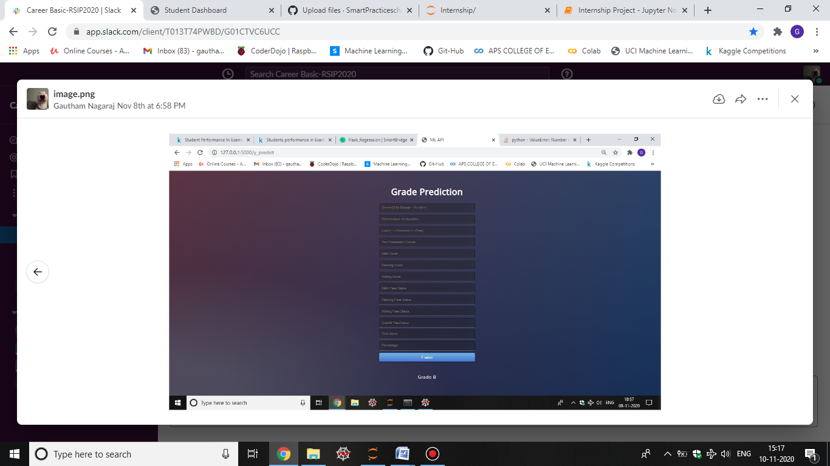

Thank You